1. create a namespace iti-devops



1. create a service account iti-sa-devops under the same namespace

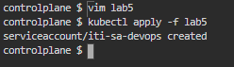

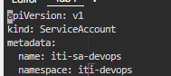

-----------------

3- create a clusteRole which should be named as cluster-role-devops to grant permissions

“get”,”list”,”watch”,”create”,”patch”,”update” to

“configMaps”,”secrets”,”endpoints”,”nodes”,”pods”,”services”,”namespaces”,”events”,”serviceAccounts”.

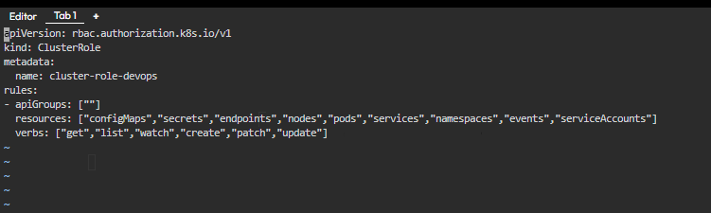

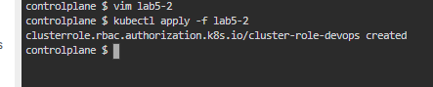

4- create a ClusterRoleBinding which should be named as cluster-role-binding-devops under the same

namespace. Define roleRef apiGroup should be rbac.authorization.k8s.io . Kind should be ClusterRole,

name should be cluster-role-devops and subjects kind should be ServiceAccount: name should be iti-sadevops

and namespace should be iti-devops

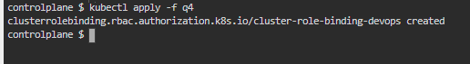

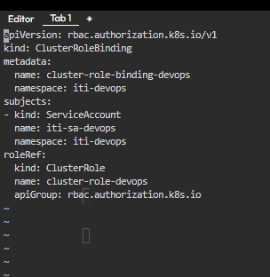

5- What is the difference between statefulSets and deployments?

*- Deployment manages multiple pods by automating the creation, updating, and deletion of ReplicaSet. Deployment, on the other hand, is suitable for stateless workloads that use multiple replicas of one pod, such as web servers like Nginx and Apache*

- *StatefulSet helps orchestrate stateful pods by guaranteeing the ordering and uniqueness of pod replicas. StatefulSet is better suited to stateful workloads that require persistent storage on each cluster node, such as databases and other identity-sensitive workloads*

6- Set up Ingress on Minikube with the NGINX Ingress Controller

play around with paths , you can create more than 2 deployments if you like

https://kubernetes.io/docs/tasks/access-application-cluster/ingress-minikube/